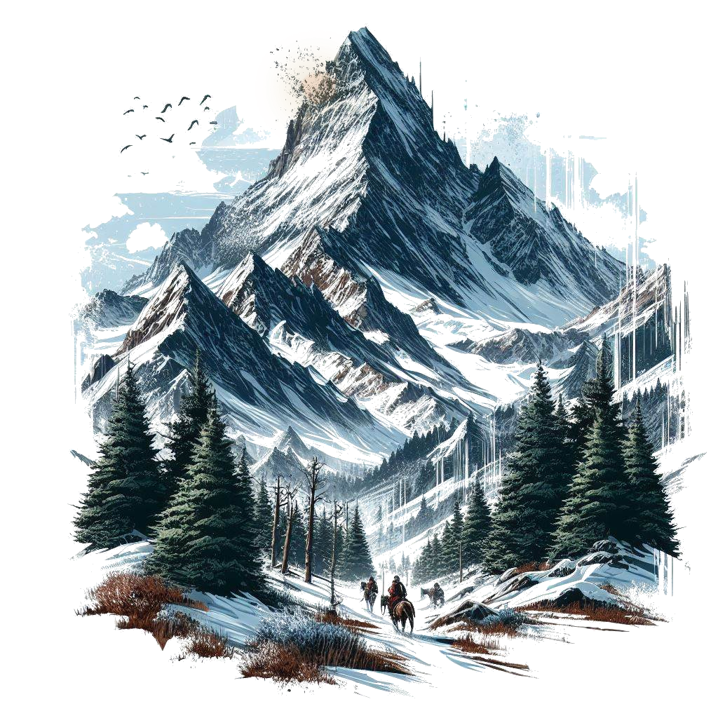







# Title Gradient 6Chapter Section

Welcome, Game Master! This book is for your eyes only. It contains the QuestGuard starter one-shot Fire on Mount Hyhelm, with instructions on how to play and organize this story for your players.

If you are not a Game Master, close this book immediately.

## Who Is This for

This book is intended for beginner Game Master and players who have never played QuestGuard. It was made to be as easy as possible to run.

If you have never been a Game Master, now is your chance.

## What To Expect

Fire on Mount Hyhelm follows a group of 3 to 5 players, on an adventure that will last one single session, start to finish (3 to 5 hours). Of course, you can do the adventure in multiple sessions, depending on the time you want to spend playing.

As a Game Master, you are **not required to read this book in advance**. Fire on Mount Hyhelm was made to be **read at a glance** - it requires minimal preparation. However, please read everything up until Chapter 1

before you begin, to learn how to use this book. Once you get to Chapter 1, simply let the book guide you.

The book contains many read-aloud sections, and flows top-to-bottom, left-to-right and will guide you through everything you need to say and do.

This adventure also teaches the players the basic rules of QuestGuard.

## Your Responsibility

As a Game Master, you will be the narrator and referee of the game. You present situations, and players will try to do things in those situations. A lot of the times, a **Check** is required (a roll of a die) to determine if the player succeeds in their action.

You will be responsible for reading passages out loud for your players, roleplaying as non-player characters (e.g. speaking in the voice of another character or conveying what they are saying), controlling the monsters in fights (e.g. rolling dice for them) and, usually, making sure every player gets their time in the spotlight and is having a good time.

# Title Gradient 6How to Read It

This section explains how to read the book and interpret the various elements.

## Read-Alouds

When you encounter text with a tan background like this one, read it out loud for the players. For example:



*You come across a narrow river that blocks your*

*path forward. The river smells of salt, thick muck*

*flows through it. What do you do?*

There will be a lot of these and they will narrate not just story elements, but also rules.

As a Game Master, **a lot of the information you have is from read-alouds**. These read-alouds will serve as information for both you and the players.

## NPC Replies

In some sections, NPC’s (non-player characters from the story) will have potential replies to say. Here is an example for a random peasant players encounter:



***“****Welcome to our village, adventurers!”*

***“****You look hungry. Head over to the tavern, they*

*serve good food!”*

***…****I did see* ***a strange man******in the******woods*** *last night!*

*…No, I never* ***stole*** *anything in my life! [lie,*

*he stole coins from the church donation box]*

You will see read-alouds with NPC replies.

The first few lines, in quotes, are dialogue lines meant to be **said directly** by the NPC (e.g. casually mentioning them in a conversation). For example, say the first dialogue line, wait for the players’ response, and if you see fit, say the next dialogue line. Rinse and repeat.

Lines starting with **…** are meant to be **only answers to questions** players ask, and should not be given without being asked specifically about the subject.

**Bold** phrases or words are emphasized to easily come into your view in case players ask about it.

If an NPC has no dialogue lines about a subject, then they don’t know about it.

## NPC’s - When In Doubt…

When in doubt of what an NPC would say, resort to them saying *“I don’t know” or a similar reply*.

Don’t worry - you will get good information on NPC’s that is easily readable at a glance, without requiring preparation. Feel free to paraphrase NPC dialogue lines.

## Suspicion (0 to 20)

Each NPC has a secret **Suspicion** level from 0 (is completely friendly and trusts the players) to 20 (will not even talk to the players or is outright hostile).

Whenever the players try to persuade an NPC and the NPC isn’t sure of what to do, have the players roll a Charisma Check at least equal to the NPC’s Suspicion.

On a successful Check, decrease **Suspicion** by 1. Otherwise increase it by 1.

If players say something insulting or fitting to the conversation, increase or reduce Suspicion by 1.

Keep track of the NPC’s **Suspicion**.

Depending on how mild or crazy the player’s idea is, feel free to secretly give a +5 or -5 to their Check.

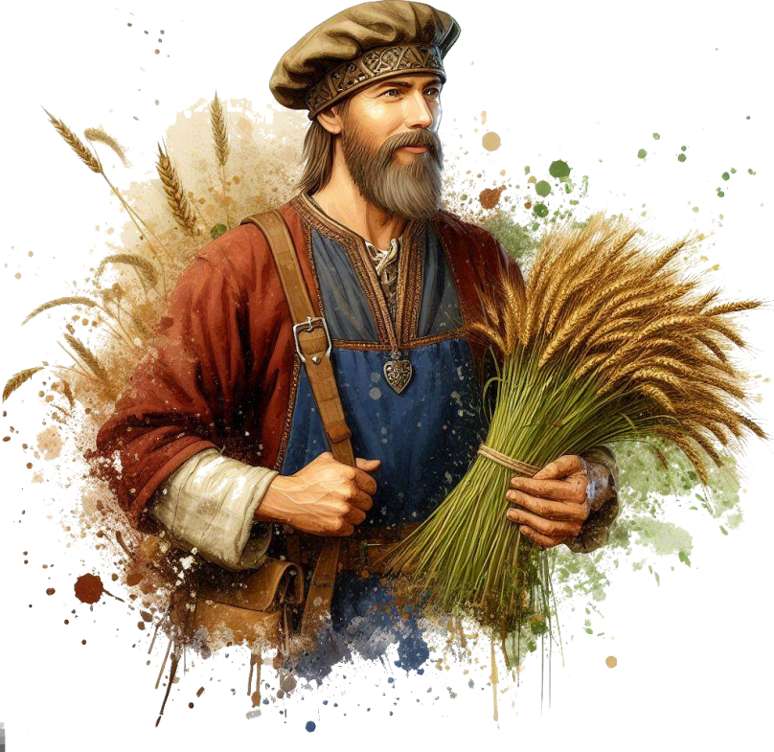Decreasing **Suspicion** will unlock certain dialogue lines

# Title Gradient 6Locations & Sections

The book’s chapters function as Locations.

Each “chapter” is a separate Location that contains read-alouds, artwork, scenarios, etc.

Here is an example:

# Title Gradient 6The Windmill

*As you ascend the winding cobblestone path, you*

*approach a decrepit fence. Pushing through the*

*rotting wood, you arrive at the entrance of an old*

*wooden windmill, now reclaimed by nature,*

*overgrown with vegetation. The air carries a*

*musty scent, tinged with the earthly smell of*

*decaying wood, hinting that has been standing for*

*centuries, untouched by human hands in many*

*decades.*

## If Sections

Some sections are titled “If…”.

Only read these sections if the title applies. If not, skip them and continue.

For example:

## If There Are 5 Players…

*As* ***[player 5]*** *enters the windmill, the floorboards*

*crack open and* ***[player 5]*** *falls through*

*into a stone basement.*

## Returning to Locations

If players return to a location or NPC, don’t repeat the same read-alouds or dialogue lines (unless they specifically ask for it).

## Props

The adventure contains paper props, such as a map, secret letters, etc. Only give these out when instructed by the book. Keep them secret until the book tells you to show it to the players.

Sometimes the book will tell you to show the players a picture of something. You can use a phone, TV screen or a laptop to show them the picture, which you will find in the Digital Appendix.

# Title Gradient 6Combats

You will have to control monsters in combats. The book will tell you how to run each monster.

## Running Combats

When running combats, try to spread the enemies as evenly as possible on the players (e.g. if you have 4 enemies and 4 players, each enemy should attack a different player). Dying in the first round is no fun!

…unless players want to spread the damage differently (e.g. if the knight wants to front-line and take the damage instead of the mage in the back).

## Battle Maps

Each combat encounter comes with a battle map, which you can find in the Digital Appendix. If you’re playing online, you can use the exact map. If you’re playing on a table with pen and paper, you can draw a sketch of what the battle map looks like.

You can skip some of the details when drawing (e.g. trees, rocks, etc) unless it specifically says that thing is important to the map.

This is what a battle map will look like **for you, in the book only**. Do **not** draw text on the map! Any annotations on the map are for your eyes only! The digital maps in the Digital Appendix don’t contain the annotations.

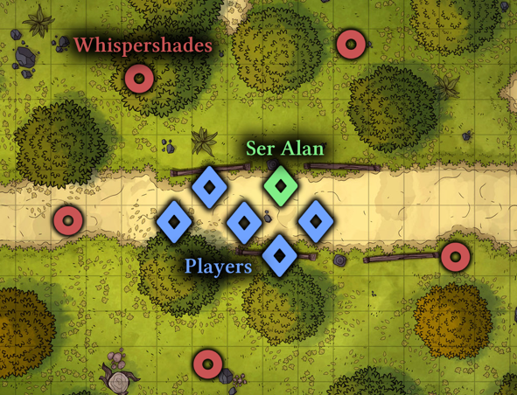

The map annotations are self-explanatory. Diamonds represent player or allied Units (creatures). Blue for players, green for allies, yellow for neutral. Circles represent enemies. Red for hostile, orange for possibly hostile

# Title Gradient 6Locations & Sections

The story begins as soon as all the players are ready and have their characters finished.

Fire on Mount Hyhelm sees the players being called for a job in a town at the base of Mount Hyhelm to investigate a strange light that can be seen on the mountain at night.

The players will talk to the mayor of the town and to the townspeople, and set off to climb mount Hyhelm. They will find strange tracks, dead bodies of lost adventurers, fight moths and spirits, and finally, confront the culprit: a part-moth woman who was feeding on lost adventurers.

When you want to present the idea of

Whispervale to your players, read the following

out loud:



*Hyhelm - mountain as old the land itself, whose*

*peak has curiously not yet been explored. Plenty*

*of adventurers have tried reaching it, yet none*

*of them has ever been seen again.*

*Lately, a strange light has appeared on the*

*mountaintop, and it seems to be correlated to*

*certain unusual happenings around the town at*

*the mountain’s base. And you were the ones*

*called to investigate and find out what is*

*troubling Mount Hyhelm.*

*You will be playing the roles of fresh adventurers*

*hiking to the town of Farwood and climbing*

*mount Hyhelm.*

*You will talk to various characters, battle*

*monsters, solve puzzles and piece together clues*

*to solve the overarching mystery of Hyhelm.*

*So ready your sword, find your notes and your*

*map markers, plan out accordingly, and immerse*

*yourselves in the story of Mount Hyhelm.*

You can give the players the extra information that they will play Level 1 characters. There are (hopefully) no elements that would make the players uncomfortable:

There is no depicted gore or disturbing visual imagery in the book, not shown, nor told. There are no disturbing visuals and no topics that would be considered “taboo” in the real society.

However, the story can be gloomy, and contain potentially unsettling monsters or unusually looking people.

It can be noteworthy that this adventure is quite “railroady” (linear), as it is intended for beginners.

## Player Backstories

Player backstories won’t really matter, unless you choose to improvise them into the story, though that can be difficult. Tell them to come up with adventurer characters. with simple backgrounds, that would accept to be paid to investigate a mystery by climbing a mountain.

The story assumes the characters did not know each-other previous to their meeting in the first chapter.

## Story Explained

A few months ago, a strange light appeared on top of Mount Hyhelm. Several people went to investigate, but none returned.

In the settlement of Farwood, the mayor’s wife, Rilda, decided to investigate herself, as she was an experienced hiker. Her husband, the mayor, refused to let her, so she snuck out during the night.

Most people (men) die on their way up due to the traps of the hermit, Hail. The hermit let her pass because she was a woman and dying of an incurable disease - she was a suitable host for the *light* on the mountain.

The hermit took Rilda to the *light*, who was actually a *possessing* *fiend* looking for a suitable host. Rilda was such a host. The light fiend turned her into a part-moth being. The fiend has the ability to attract people to it, like moths to a flame, and devour them.

The players will have to kill Rilda (the light fiend), and Hail the hermit (optionally).

# Title Gradient 6Rules To Remember

Follow the script of the adventure - it will tell you exactly all you need to do and say. No need to improvise, unless you want to.

Players will not Level Up, nor will they regain full resources until the end of the story (there is no such thing as a *Long Rest*).

If a player falls to 0 Health, they become Fallen and must skip their turn. When Healed, they get back up with Exhaustion (halved Actions and Speed). When a monster reaches 0 Health, it dies.

For all intents and purposes, players can’t die this adventure, unless they do something really stupid. No combat should be hard enough to have players wipe.

## What Players Should Know

From the start, the players should know the following:



*Before we begin, here are some things you should*

*know: you should track your own Health, Mana and*

*resources, since they will keep changing.*

*It will also be very useful to take notes, as there*

*could be information you need for later.*

*You will be fighting monsters, solving puzzles and*

*talking to various characters throughout the*

*adventure. There will be a few combats, a decent*

*amount of roleplay, and puzzles, taking roughly*

*33% of the entire session each. The story is rather*

*linear, but there will be choices to make.*

*Note that every non-player character may like or*

*dislike you, and everything you say to them will*

*influence how they react, what they do and how*

*much they trust you.*

*As an ethical guideline, try not to split the party,*

*interrupt people while talking, and remember that*

*the Game Master always has the last word.*

*Most importantly, have fun and make sure everyone*

*else is having fun, too!*



# Title Gradient 6Road to Farwood



*Just a while ago, you gathered with your companions*

*along a winding path through a pine forest, steadily*

*gaining altitude as you get ever closer to the*

*mountainside. It is a clear winter day, the sun*

*illuminating patches of snow nestled among the*

*green fir trees.*

*On the distant horizon, a magnificent snow-capped*

*peak reaches towards the clouds behind the woods.*

*You are all traveling to the mountainside town of*

*Farwood, where you were summoned via a job*

*poster for a mission atop the very peaks of the*

*mountain before you - Mount Hyhelm.*

*On your travel thus far, you’ve had ample time to*

*bond, and trust each other that you are a team on*

*the same mission, watching each other’s back.*

*[As GM] One by one, describe your characters’ name,*

*race, class and personality.*

Wait for the players to describe their character, each (you can go in a circle), then continue.



*As you press onward up the mountain trail, the path*

*narrows, requiring caution to avoid slipping down*

*the lightly snowy cliff to the side.*

*Your journey comes to an abrupt halt as you*

*encounter an obstacle: a thick fir tree lies fallen*

*across the road, blocking your path forward. To your*

*left, a steep cliff descends several meters, while to*

*your right, a sheer rock wall rises.*

*Working together to overcome this obstacle, what*

*do you do?*

## While they are thinking…

Let players come up with a solution.

If something they do requires any amount of effort, they will need to roll a Check - a d12 (12-sided die) roll, to which the player can add their Stat. If a Check requires physical strength, they can add Might. If it requires mental effort, they can add Intelligence. And so on.

A medium-difficulty Check usually requires the final result to be at least 10. Feel free to alter this number by -5 or +5 (or other numbers) depending on how hard you think the Check is. Note that rolling a 12 counts as a 15! Players might also have Skills (see below).

For this challenge, there are no drastic consequences to failure, but failing a Check usually means they can’t

attempt it again.

For example, jumping over the tree is not very hard (roll at least 10 on a Dexterity Check). Lifting the tree is more difficult, and will require a combined total of 20 from the sum of multiple people.

Whenever you reach this point, continue:



*If any of you has a Skill that you think will be useful*

*in this situation, let us know. They are written under*

*the Skills box on your character sheet.*

*Being Skilled in something means you can also add*

*+1 to your roll! If you are Skilled in Jumping, and*

*want to jump over the tree, you can add an extra*

*+1 to your roll!*

*This +1 comes from your character’s level, which is 1.*

*Whenever you feel like you have a Skill that would be*

*useful in a situation, make sure you say so!*

When the players manage to get past the tree, lightly narrate their success, and continue.



*Continuing along the winding path towards Farwood,*

*the daylight wanes, due to the winter’s early sunset.*

*As you press onward, it is slowly getting darker and*

*darker.*

*In this dark evening, you are met with a comforting*

*sight of wisps of smoke dancing on the horizon,*

*signaling your approach to civilization. The dirt path*

*beneath your feet transitions into cobblestone, and*

*stepping beyond the shroud of dense trees, the*

*silhouette of the town comes into view, beckoning*

*you closer with its promise of shelter and warmth.*

*You are now entering Farwood.*

*The village comes alive in the soft glow of torchlights,*

*from people roaming the streets looking to end their*

*day’s work. Spruce log homes, both small and large,*

*dot the roadside, lending the village its rustic charm,*

*filling the air with a smell of stew, fresh bread and a*

*hint of burning tobacco.*

*Moving forward along the cobblestone path, two*

*guards perched atop a snow-covered tree stump*

*watch your approach with keen gaze.*

*But soon, their gaze locks in a different direction: up.*

*Looking above you, toward the large mount Hyhelm,*

*you can see a faint, orange glow, up high on the very*

*peaks of the mountain.*

*You figure* ***that*** *is the far away mysterious light*

*you’ve been called to investigate.*

*It is nearing 7:00 in the evening. You are in the central*

*marketplace. The path forward leads to a large, town*

*hall-like-looking building, while the road to the left*

*seems to go toward a tavern.*

*What do you do?*

Players might go to any of the following:

* *Town hall (Hadden)*
* *Tavern (Chew)*
* *Guards & Marketplace*

When the players decide to go to any of these, flip to that location’s page.

# Title Gradient 6Town Hall (Hadden)



*You journey onward toward the large building over*

*yonder, also made of dark wood, with a fine stone*

*base and a beautiful roof of a differently colored*

*wood.*

*You are greeted by a couple of guards, wearing a*

*green and red outfit, with a chain mail shirt and*

*capes made of thick hide. One of them is a human,*

*in his 40’s, and the other one is a grizzled dwarf,*

*each carrying an arming sword on their belt.*

*The human takes a few steps forward towards you,*

*and greets you:*

## Guard Edgar

From the start, the players should know the following:



*“Halt! Who does there?”*

*“What is your business with Mayor Hadden?”*

*[If it’s evening] “It is quite late, I don’t think Mayor*

*Hadden has time for you right now…” [the players*

*might be able to convince him to let them in; they*

*would need to roll a Charisma Check at least 10]*

*[If it’s not evening] “You’re in luck - there are no*

*other appointments at this time of day. We’ll take*

*you in.”*

*“If you wish to go inside, you’ll have to leave your*

*weapons here at the door.”*

*…The dwarf guard? Name’s Gorad. He is mute, he*

*doesn’t speak.*

*…Light on the mountain? Oh yeah, it’s been there*

*for a while. I think it’s dimmed lately. Maybe it’s*

*gonna extinguish soon…*

*…Called for a mission? Ah… good. Finally someone*

*to go up there and see what’s up. I would go myself,*

*but I’ve got a family and all… too risky for me, and*

*for my partner here Gorad.*



*The guards take you to a room, just inside the large*

*building. Knocking soflty on the door, they receive a*

*faint “Yes?” response from inside. Guard Edgar*

*opens the spruce door, his boots dripping melting*

*snow on the gray fur carpets laid on the floor.*

*Inside the room, a cozy fireplace is lit, and on the*

*other side, a large desk with shelves over shelves of*

*documents set against the walls.*

*Sitting cross-armed on the edge of the dark wooden*

*desk, a figure stands no taller than 1.80 meters.*

*Though his height is greatly increased by an ornate*

*hat.*

*The man looks at you with piercing eyes, of a light*

*brown hue. You can identify no intense emotion on*

*the man’s face - his gray goatee and sideburns*

*would have given it away.*

*[If it is evening] “You have finally arrived. I couldn’t*

*have waited any longer. Welcome.” says Mayor*

*Hadden with a tired voice, and then addresses the*

*guard: “Close the door, would you? Thanks.”*

*[If it is not evening] Mayor Hadden looks a his*

*ticking clock on the wall. “You know I deliberately*

*did not take any appointments, at this exact time?*

*I was right. Not a minute late, nor early. Welcome!”*

*says Mayor Hadden with a tired voice, and then*

*addresses the guard: “Close the door, would you?*

*Thanks. Let’s talk.”*

## Mayor Tom Hadden



*“Have you ever been to Farwood, friends? No? It is*

*both beautiful, and terrifying, especially at night.”*

*[If evening] [Mayor Hadden goes to the window and*

*points] “That thing. The light. Now that’s creeping*

*us all out.”*

*[If day] “Not sure you can see it properly at this time*

*of day, but… if you look closely… [Mayor Hadden*

*goes to the window] You can clearly see it. Up there.*

*The light. You’ll see it when it gets darker, I’m sure.”*

*“That light has been there for months. Nobody*

*managed to reach it. And several people have tried,*

*though none has returned.”*

*“Not long ago, the light was shining brighter. Lately,*

*it has dimmed. As if the light has quieted down, for*

*some reason…”*

*“Something else started to happen since the light*

*dimmed. People of Farwood have been disappearing.*

*A strange coincidence, do you reckon? Now, if the*

*two are correlated, I want to know why. And stop it.”*

*“I want you to go up the mountain. First and foremost,*

*find out who or what is messing with the people, and*

*deal with the problem. Second, I want to know what*

*the light is, and, if it’s dangerous, deal with it as well.”*

*“Here…” [Mayor Hadden throws you a bag from under*

*the desk] “300 gold upfront. 700 more when you’re*

*done. There is a road through the forest, leading up*

*the mountain. After a certain point, you will need to*

*hike. The road only goes so high. Make sure you buy*

*whatever supplies you think you will need, from the*

*Town’s marketplace.”*

When the players are done, they may go up the mountain, to the tavern, or to the marketplace.

## *Tom Hadden (Mayor Hadden.png)*

Base Suspicion: 10

Smart, tidy, but a bit smug.

Feel free to show the players a picture of *Mayor Hadden*.



*…****People who disappeared****? In the past few weeks, we*

*have had 3 men who were never seen again… and a*

*woman. We believe they all went up the mountain of*

*their own volition. Ask the townsfolk around Farwood or*

*in the tavern.*

*…****Their families****? I know some of them, yes. But you’re*

*better off asking around town, see if you can find their*

*friends and family. They’re busy people.*

*…****My wife, Rilda****?* ***[requires Check]*** *I haven’t told you this.*

*Perhaps I should have. I don’t know where she is. Up the*

*mountain, I hope you will at least find her body. it’s*

*where she went, alone, and we could not find her. I*

*apologize… it is hard to talk about it…*

*…****Rilda being sick****?* ***[requires Check]*** *She had a disease…*

*we tried clerics, and doctors, but it was futile. There is a*

*hermit up the mountain, into the occult arts. I expect she*

*went to see the hermit, looking for a cure. I disagreed…*

*what with the people going missing… she went at night,*

*when I was sleeping.*

# Title Gradient 6Tavern (Chew)



*The cobblestone path through Farwood takes you to*

*the western side of town, where a large, single-story*

*tavern spans the whole width of the street. Above it,*

*a worn, wood-carved sign reads “Boar’s Hoard”.*

*Stepping in through the creaking door, a single*

*colossal chamber unfolds, its high ceiling adorned*

*with hanging lanterns that cast a flickering glow*

*upon the patrons - some sleeping in hammocks, and*

*some having a bite to eat. Judging by the smell -*

*venison.*

*At the heart of this bustling establishment, a small,*

*wide figure clops around. His tusks gleam with pride,*

*and his brown fur smells of grapefruit liquor.*

*It is a boar-folk Bertle bartender, trying to reach the*

*opposite end of the tavern with several dirty plates*

*stacked one on top of another.*

If the players want to talk to him, feel free to have other people around join the conversation freely. Change the person speaking at will (most of the following dialogue lines can apply either to the bartender, or people around).



*“Ho there! Easy now, have a seat! Food? Drinks? Some*

*citrus for the ladies? What can I get you?”*

*“You talked to the mayor, huh? He can seem pretty*

*tough. Poor bastard’s never been the same since his*

*wife vanished, a few months back. He won’t talk about*

*it, no. But we all know barn well that’s the main reason*

*he hired you. To find his wife.”*

*“You know, there really is a hermit living up there, goes*

*by Hail. I expect Hail did some of that black magics.*

*Used to be a common-folk years ago! Nobody really*

*knows Hail, really. It’s all just rumors. But if you’re*

*looking for a troublemaker, that’s your lead.”*

*…****Mountain trail****? Oho, expect some 2, maybe even 3*

*days’ hike to the top. Better be well-prepared!*

*…****People who disappeared****? Ho, let’s see… A hunter -*

*Stok, went into the forest for game and never came*

*back. Had a dwarven rifle. We also have a missing*

*camper - he goes camping several times a year. There*

*was also an old elf pilgrim. Goes up to the shrine all*

*the time. This time, he did not show back down…*

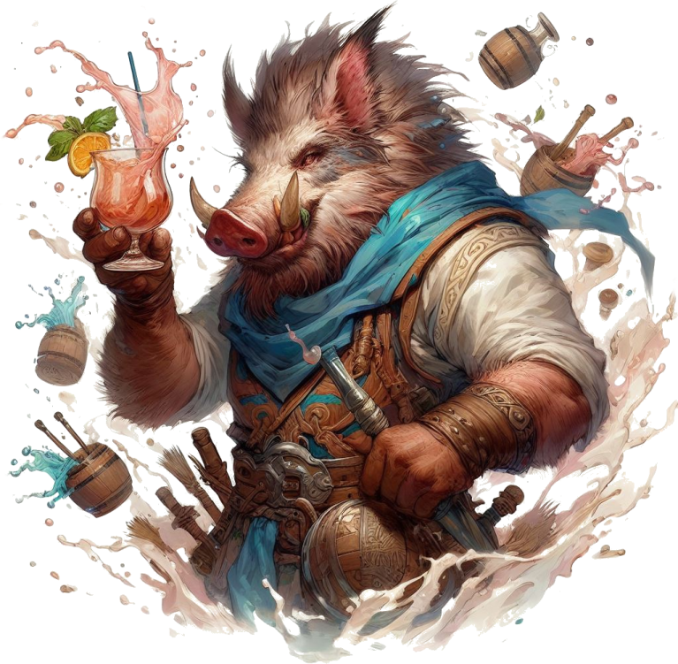

## *Gow “Chew” Boaris (Chew.png)*

**Base Suspicion**: 7

Very friendly and stocky. Loves a good smell.

Feel free to show the players a picture of *Chew*.

Rents rooms for **10g per night** (per person). Offers meals for **5g per mea**l, and **2g per drink**.



*…****The hunter, Stok?*** *Went to hunt moose, most likely, one*

*week ago. Fine dwarf. Just wants to provide for his*

*family.*

*…****The hiker, Triny****? A gnome hiker. Likes to find berries*

*and catch birds. Lived alone right here, in this tavern.*

*Made his coin off of his flute shows. Went missing 2 or*

*so weeks ago.*

*…****The pilgrim, Wonnen****? Old elf. Was the main cleric of*

*our town. He is what we call a “generic priest” - knows*

*all sorts of things about all sorts of religions and all. He*

*was reported missing just 2 days ago.*

*…****The light****? It’s been there for a year, give or take.*

*…****The light dimmed****? Ho, I never really noticed it. Yeah,*

*you’re right! I do believe it’s dimmer now! Huh…*

*…****Mayor’s wife****? Rilda was her name. Rumor has it she*

*went to investigate the light herself, but never came*

*back. This was some weeks ago, I think?*

*…****The hermit, Hail****? Wish I knew more. Lives past the*

*cleric’s shrine, up on the mountain.*

*…****People investigating the light****? There have been*

*attempts, over the year. None came back…*

# Title Gradient 6Marketplace

If players first went to the mayor or the tavern for the day, the marketplace is closed. They must return tomorrow to buy things.

They may still ask people around for clues.



*At the heart of Farwood, a small town center forms*

*around an old stone water well, makeshift tents*

*surrounding the area. It is not bustling.*

*[If evening] At this hour, most of the people of*

*Farwood have packed up and gone back to their*

*homes, and the ones who haven’t left already are*

*doing this very moment.*

*[If day] The marketplace is open, plenty of shops set*

*up selling food, tools, and maybe even a magic item*

*or two.*

## Prices & Items Available

When they want to buy items, show them the **Prices** sheet from the appendix. That’s all the marketplace has to offer in Farwood.

If they ask, players may get a discount equal to their 5 x Charisma.

## Commonfolk Dialogue

These dialogue lines apply for sellers, random folk,

etc. Feel free to improvise names and personalities.



*...****The mountain****? It’s our natural beauty! Make sure*

*you are well equipped for camping and the cold!*

*..****.People who disappeared****? Well we’ve got the*

*mayor’s wife, Rilda, Wonnen the generic cleric, Stok*

*the dwarven hunter, Triny the gnome, and a bunch*

*of other adventurers, months back.*

*...****The hunter, Stok****? Traded meat and hides. Went*

*hunting one day, and poof! Never seen again! Now*

*we’re stuck eating carrots and lettuce!*

*...****The pilgrim, Wonnen****? Well, holy damn, we miss*

*him gravely! There’s a shrine up in the mountains, he*

*used to go pray. If you go out there, do look for him!*

*The shrine is right on the trail through the woods, you*

*can’t miss it!*

*...****The light****? Well, lo and behold! It’s our town’s*

*touristic attraction! Reckon we can make some coin off*

*of it. Been there all year! Some say it’s a fiend or a*

*demon or so. I don’t know, it helps me fall asleep at night.*

*…****The light dimmed****? Yeah, it did! A few weeks ago! Hope*

*it doesn’t extinguish itself too soon! I quite like it!*

*…****Mayor’s wife, Rilda****? Now that woman was something*

*else! A beauty worth no one’s eyes! Rumor has it she was*

*slowly dying of a disease. Who knows if it’s true. But my*

*guys, let me tell you, she was drawn to that light like a*

*moth to the flame! Curiosity killed the cat, I say!*

*…****The hermit, Hail****? She’s freaking insane! Into the*

*occult and all. Summons demons, breathes fire, and all…*

*They say she was a villager of Farwood, back in the day.*

*No villager I know that I’d let summon demons! I tell ya!*

*Wanna find her? Head up the mountain, past the shrine.*

*She’s more than a day’s hike, though. I’d definitely start*

*questioning her! I think she left the village right about*

*when the light first appeared!*

*…****People investigating the light****? People come and go.*

*Now that I think about it… other than the mayor’s wife*

*and that hermit, don’t think I’ve ever seen a woman go*

*up there. Just men.*

*…****Dangerous****? As long as we didn’t go too far up the*

*mountain, we used to be safe here! Seems nowadays*

*you can’t even go for a stroll!*

# Title Gradient 6Base of the Mountain

*As you ascend the mountain road, the chill in the air*

*grows sharper. Snow starts to blanket the landscape,*

*the atmosphere well set by the occasional sight of a*

*deer and other wildlife. The road goes up, with a small*

*clearing forming on your right.*

*The crisp scent of pine invigorates your senses, and,*

*while you notice traces of past human travelers, they*

*appear normal, without any cause of concern. No*

*suspicious sight yet. By this point, you’ve been walking*

*for several hours.*

*[As GM] The person furthers in the front - make a*

*Sense Check, maybe you can see something useful.*

*[If at least 8] Dried on the bark of a tree, you spot a*

*redish smear. You approach to investigate further, and*

*notice red marks going off-trail toward the clearing*

*on your right.*

*[if not] You believe there could be a bear, or a wolf,*

*nearby, so you tread carefully through the snow. It*

*should not pose a threat to your party.*

*[Continuing] You still have a solid few hours of*

*daylight before you would have to camp the night.*

## If they go to the clearing…

*Headed to the clearing, you spot more and more*

*such spots on the trees.*

*[If a player wants to find out more, they must roll a*

*Sense Check at least 10] It looks as if someone was*

*running away from something. You spot very old boot*

*marks underneath the snow, dwarven sized.*

*[Continuing] About 100 meters in, something shines*

*in the snow. [If players go to investigate] It seems to*

*be a hunting gun [give the players Stok’s Gun].*

*[Continuing] Over yonder, you spot a body, fully*

*covered in snow.*

*[If players go closer to investigate] You try to wipe the*

*snow off of the body, but touching it makes it blow in*

*all directions, like a puff of smoke. This isn’t snow that*

*was covering the body. It’s a form of soft, white fur.*

*You recognize that this is the body of a dwarf.*

*[Sense Check -- at least 5] The dwarf’s body seems*

*partially eaten, mostly by small bite marks.*

*[At least 8] You can see a lot of small holes in his*

*clothing.*

*[At least 11] There are no other trails except some*

*small holes in the dirt, under the snow, no thicker than*

*10 centimeters in diameter, as if someone had*

*inserted stakes or spikes in the dirt, and removed them*

*afterward.*

*[At least 13] There is a subtle, sticky white dust also*

*stuck to the trees around the area. Simply inhaling it*

*starts to make you feel tired.*

*[Continuing] You are able to scavenge what you can from*

*the dead dwarf’s backpack and pockets. [Give the players*

*Stok’s Loot from the appendix].*

## Continuing…

*You continue up the road, spending the next hour*

*hiking along the road. As you ascend, it gets*

*progressively more difficult to climb - steeper and*

*less paved.*

*Daylight is now starting to wane, but you soon spot*

*a silhouette up in the distance, of what seems to be*

*a stone obelisk.*

*Someone make a Sense Check.*

*[If rolled at least 12] Up in a tree, not far from your*

*position, you see a small wooden effigy. A pagan sign*

*in the shape of an infinity sign made of sticks and tied*

*with rope.*

*[Let the players find a way to get it down if they want]*

*[If they do, give them the Effigy from the appendix]*

*[Otherwise] The obelisk in the distance is unmoving.*

*[Continuing] As you approach, you see some holy*

*runes on the obelisk, marking that this is likely the*

*a religious shrine, used for prayers by pilgrims.*

*That is not the only thing you notice.*

*From behind the tree appears a large floating animal.*

*It looks like white butterfly, or a giant moth, its silvery*

*wings as imposing as its huge fangs.*

*Another one appears from around the cliff, flying*

*toward you with intent.*

*You are being attacked by them! Roll initiative!*

# Title Gradient 6Moths Combat

*From the effigy, another strange creature resembling*

*a spectral serpent emerged, attacking the party!*

The map is in the appendix (*Battle Map Shrine.png*).

Players are coming from the bottom, going to the top.

Put one player near the shrine (top-right-center).

Put the rest of the players wherever appropriate, depending on where they said they would be (or put them randomly, in the vicinity of the player near the shrine).

Put the Moon Serpent anywhere near the effigy (the bottom-most tree, or the players if they took the effigy).

Spread the rest of the moths evenly, so that no one player is overwhelmed.

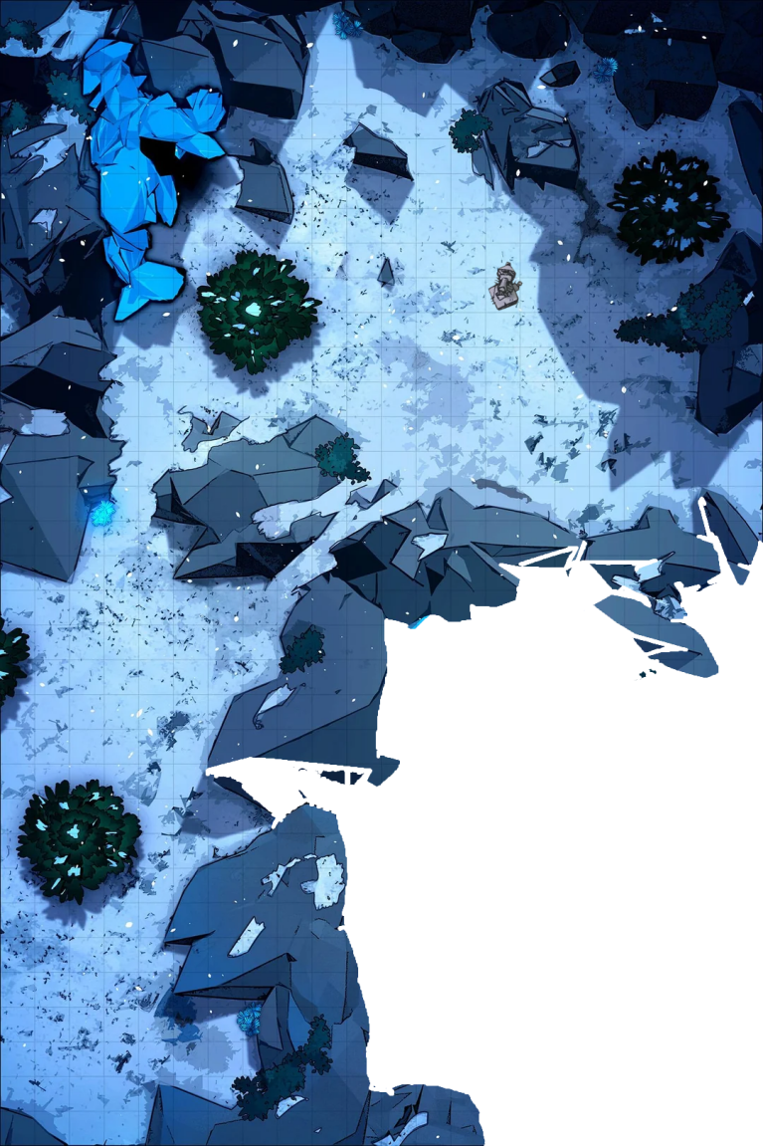

 *[As GM] Everyone roll a 12-sided die and add your*

*Initiative number to that roll.*

*You will take your turns in the order of your turns.*

*Higher Initiative goes earlier, lower goes later.*

*Monsters have fixed initiative, and don’t roll.*

*For example, these moths have an initiative of 8.*

*The spectral serpent has an initiative of 4. If you*

*rolled above or equal to 8, you go before them all.*

You (the Game Master) need to play each monster accordingly.

Each monster, on its turn, has 1 Action and can move. Monsters with the same initiative can take their turns in any order.

## When combat is over

*As the final moth takes its last breath, you spot at the*

*corner of your sight a figure watching over you from*

*ahead, which quickly takes off and disappears into the*

*white landscape contrasting with the late day’s*

*darkening sky.*

*Looking up, you can see you are closer to the*

*mysterious light, yet not close enough to discern any*

*of its qualities, other than its yellow-ish color.*

*It will soon be night time.*

## Night on the mountain

*As the night draws closer, it is also progressively*

*getting colder. The path goes forward, through*

*rocky passages and snowy clearings.*

*What do you do?*

The mountain is very cold at night.

After a bit of time, ask every player to make a Might Check to see how well they resist the cold.

If they get at least 15, they’re fine.

Otherwise, they will take 4 Damage (spread among the next 4 hours).

If a player has taken proper measures to resist the cold (e.g. buying thick clothes), secretly give them a +5.

Improvised clothing will give them +2.

Fire will give +2.

Any other measure may give them +2.

## If they make a fire (or torches)

*You notice strange small moths gathering around the*

*fire, flying around it. It is no swarm, but their wing*

*flaps are enough to block part of the heat and light*

*emanating from your flame.*

## Night’s end

The night passes without any other events.

# Title Gradient 6Mountain Path

*The path up ahead is clear, and you take to it and*

*carry on your hike.*

*Daytime on mount Hyhelm is more forgiving than the*

*cold night.*

*As you traverse the snowy mountain path, you soon*

*reach a sort of crossroads: the path splits into two*

*diverging routes. The left side leads towards a distant,*

*weathered rope bridge you can see from a distance.*

*You spot human tracks leading that way.*

*Alternatively, the path to the right winds along the*

*mountainside, its rocky terrain hinting at a more*

*challenging route.*

*What do you do?*

Broken Bridge



*Continuing along the left side of the winding mountain*

*path, you navigate through snow covered terrain until*

*you reach an abrupt halt. Before you lies a 5-meter*

*wide chasm, falling down all the way to the depths*

*of the mountain. There appears to be no way round it,*

*and the rope bridge you glimpsed earlier from afar was*

*merely a scaffolding.*

*Unfortunately, the majority of the bridge is collapsed,*

*now hanging down from your side of the cliff.*

*What do you do?*

Depending how difficult what the players want to do is, make them make Checks (5, 10, 15 or even 20 difficulty).

Jumping the chasm requires a 15.

*Remember that a natural 12 counts as a 15!*

There are several ways to cross the chasm; let players improvise.

Avoid having the players fall down the chasm to their death (e.g. save them if that happens).

## Continuing

*Having fully traversed the chasm and rounded the*

*corner on the road, your attention is drawn to a pair*

*of legs that can be seen from the roadside. A strange*

*rumbling noise emanates from that direction.*

*As you cautiously approach, you see blood splatters*

*on the ground.*

*Drawing nearer, you discern another horrifying figure*

*hunched over the corpse.*

*What you are looking at is no human, nor beast. It’s a*

*grotesque amalgamation of a woman and a moth, its*

*wings spanning several meters, eyes glowing like red*

*fires, and razor-sharp claws on its hands.*

*The moment your eyes meet, it locks its gaze on you,*

*alert to your presence.*

## If players want to fight or talk

*The figure seems confused at your gestures, and quickly*

*spans its wings. With a couple of flutters, it flies away up*

*the mountain, and out of sight.*

## Otherwise, or if players **really** want to fight

*The figure is enraged. Getting up from its hunched*

*position, it spreads its hands, preparing its claws to strike.*

*Roll initiative!*

This will trigger an early boss fight.

Go to **Rilda Boss Battle**.

Return to the **Corpse in the Snow**. When finished.

## Corpse in the snow

*Drawing closer to the fallen figure in the snow, you*

*uncover the half eaten remains of an elderly elf man.*

*His attire suggests he was a cleric, adorned with*

*symbols of several faiths. Remarkably, his supply*

*pouch is intact, and within it, you discover a small*

*journal containing hastily scribbled notes.*

Give the players **Wonnen’s Pouch**.

Rocky Pass



*Venturing along the right side of the path, the terrain*

*grows increasingly challenging, with steep descends,*

*jagged rocks, and frost-covered cliffs.*

*The rock formations eventually turn into the entrance*

*to a cavern.*

*As you cautiously step inside, you are enveloped by its*

*gloom and cold. Gradually, your eyes adapt to the dim*

*light, and you spot an unsettling sight to the side: a*

*peculiar organic structure, resembling a cocoon.*

*However, as your gaze shifts, a sense of foreboding*

*washes over you when you realize the entire cavern is*

*filled with cold moth cocoons, coating every inch of*

*the ceiling and walls.*

*You just stumbled upon a nest.*

*Directly ahead stands a steep cliff rock ascending*

*around 4.5 meters, almost completely vertically. It*

*appears the only route forward among the incubating*

*giant moths.*

*What do you do?*









# Title Gradient 6Chapter Section

Use this template for homebrew. It is similar to what the final version of the book will look like.

You’re free to edit and adjust it to your liking.

You have all the specifications in the README file.

The font used is LinuxLibertine (you will have to install it on your computer).

Select this text together with the chapter section, copy it and paste it.

The underline should be 5 pixels below the ‘p’ immediately after the graphic goes below the chapter section.

The Chapter Section should always be on the left.

Always use copy paste for these elements to preserve the format.

## Subsection

This is a subsection. No special rules.

## Background & Details

After you’re done with a page, you can copy and paste the gradient from the top and bottom of the page.

## Title Text

For a main title (like QuestGuard), use the PSD template on <https://photopea.com> (or Photoshop) to create your title. Create a new text based on the specifications with the text tool, then overlay letters one by one over your font letters. Then delete the text and keep only the overlapped letters.

Oh yeah, and you need to load the Eczar font into Photoshop.

## Readme

For the specifications of the font, document, etc, see the README file.

Chapter Section

This is an alternative look for the Chapter Section.

## Supsection

This is another example of a subsection with some normal text, and following it is an aside box.

You can use this for **read-aloud text**.

*Here we have a nice little aside box. Use*

*Calibri* ***Italics 10.5px*** *when working with this.*

*By the way [this is not meant to be read aloud].*

*Also, leave 1 space of indentation to the left.*

*And make sure there is enough space on the right.*

*This text is just a continuation of the text*

*above, in a different font.*

Feel free to resize the aside box background as you see fit. Also, here is a list, also Calibri I. 10.5px:

* *Small lamp*
* *25 gold in leatherworking materials*
* *Shortsword*

That was a list. Use copy/paste to paste the list.

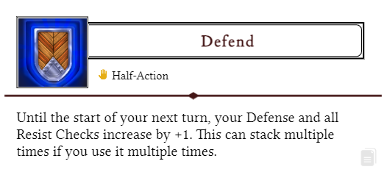

That was an Ability from the website (using the copy/paste button from the Ability box).

## Artwork

This text works

great with the goblin

on the right side of the

screen and the artwork

fits well. Lorem ipsum

dolor sit amet tristique

delirium sumus but take

into consideration that

the text should be

just long enough to fit here

nicely. The easiest way to

add artwork like this is to just

set its box to “behind text” and

you will be able to move

it around without doing

anything wicked to the

text, and gives you full control of

how you position your text. Use

spaces and enter with courage,

lads!

## Tables

Copy and paste this table when you want to create one. Pretty simple.

|  |  |  |
| --- | --- | --- |
| **Dice Roll** | **Description** | **Effect** |
| 1 | Stun | Target skips its next turn |
| 2 | Slow | Target has -2 Movements |
| 3 | Charm | Still not sure to this day |
| 4 | Exhausted | Half movement & actions |
| 5 | Fumbling | -2 to all rolls |
| 6 | Dazed | Halved actions, sir! |

That was a table. The background gradient is just an image, good luck moving it. If your table is on the left, you might want to flip the gradient for the rows.

